Dear

We would like to monitor your blood pressure.

Enclosed is a monitoring chart and we would be grateful if this could be completed and returned to the surgery.

Many thanks

My Home Blood Pressure Monitor Diary

 | Date | 1st Blood Pressure  (mmHg) | 1st Pulse  (beats/minute) | 2nd Blood Pressure  (mmHg) | 2nd Pulse  (beats/minute) | Comments
Day 1 AM |  | / |  | /
PM |  | / |  | /
Day 2 AM |  | / |  | /
PM |  | / |  | /
Day 3 AM |  | / |  | /
PM |  | / |  | /
Day 4 AM |  | / |  | /
PM |  | / |  | /
Day 5 AM |  | / |  | /
PM |  | / |  | /
Day 6 AM |  | / |  | /
PM |  | / |  | /
Day 7 AM |  | / |  | /
PM |  | / |  | /

Average | /

How to calculate your Average Blood Pressure:
Ignore the first day of readings (as this was when you were getting used to the monitor) and take an average of the remaining readings.
Add up all the top systolic blood pressures & divide by the number of blood pressures done, then repeat with the bottom diastolic blood pressures.
How to choose the right Blood Pressure Monitor
For a list of clinically validated monitors, visit https://bihsoc.org/bp-monitors/for-home-use/ or discuss with your pharmacy.

Where can you buy a blood pressure monitor?
You can buy blood pressure monitors directly from the manufacturer, from many local pharmacies, from pharmacies such as Boots and Lloyds Pharmacy either online or in large branches, or online from retailers such as Amazon and John Lewis.

Before using the Blood Pressure Monitor
• Avoid things that can raise your blood pressure in the short term. Don't measure your blood pressure within half an hour of eating, smoking, drinking caffeinated drinks such as coffee, or exercising. You should also avoid measuring your blood pressure when you need to use the toilet.
• Always measure your blood pressure in the same arm. You should use the arm which your doctor or nurse uses when they take your blood pressure,
• Wear loose-fitting clothes. Avoid wearing tight or thick clothing, as this could affect the fit of the cuff around your arm and the reading.
• Rest for five minutes before you take your reading. Sit down somewhere quiet, ideally at a desk or table.
• Make sure your arm is supported and at the same level as your heart. Position yourself so that your arm is resting on a surface and is at the same height as your heart. Keep your arm and hand relaxed, not tensed and feet flat on the floor.
• Make sure you are relaxed and comfortable.
• Write down the numbers into your blood pressure diary below.

Using the Blood Pressure Monitor and Monitoring
You can access this YouTube video which shows how to use a blood pressure monitor: https://youtu.be/AXCFcftkric
1. Follow the instructions that came with your monitor.
2. The cuff should be placed about 2cm above your elbow to make sure it can detect the artery in your arm.
3. Keep still and quiet while you take your reading. Make sure you don't cross your legs, as this will raise your reading.
4. Take at least 2 blood pressure readings, 1-2 minutes apart, each morning & evening, ideally for 7 consecutive days.
5. If the first two readings you take are very different, take 2 or 3 further readings.
6. Write your readings in your blood pressure diary below exactly as they appear on screen. Do not round the numbers up or down.
7. Return the Blood Pressure Diary (& BP monitor if borrowed) to your GP practice.

How often should you measure your blood pressure?
When and how often you take your readings will depend on your blood pressure. Speak to your doctor or nurse about what’s suitable for you.

When to seek medical advice 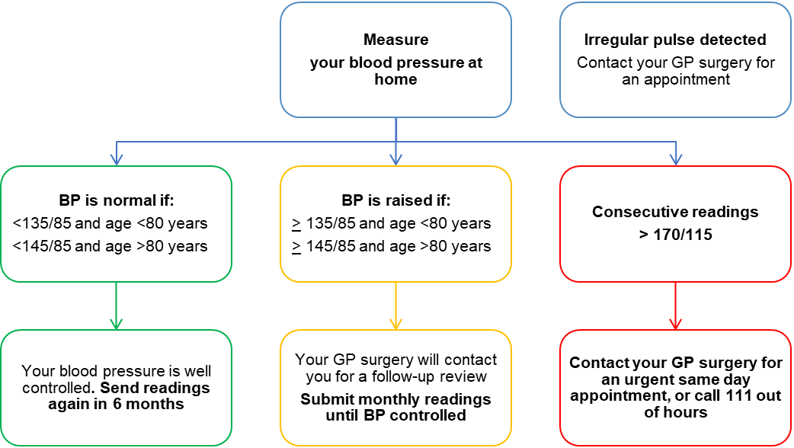
KEY
< Less than
> More than

If you have not discussed your results or been contacted within 2 weeks after returning this diary, please contact your GP surgery

Resources
http://www.bloodpressureuk.org/your-blood-pressure/how-to-lower-your-blood-pressure/monitoring-your-blood-pressure-at-home/
https://bihsoc.org/resources/bp-measurement/hbpm/
https://www.england.nhs.uk/ourwork/clinical-policy/cvd/home-blood-pressure-monitoring/

